1. Website Specifications
1.1 Website Objective and Goals
The objective of the website is to establish a strong online presence for Citrus Grove, a 100% citizen-owned company specializing in high-quality fabrics, furniture, bed linen, and interior decor products. The website will serve as a digital platform to showcase the company’s wide range of products and services while promoting its brand identity and design philosophy.
The primary goals of the website are:
- To increase brand awareness by showcasing Citrus Grove’s premium products and services to a wider audience.
- To attract potential clients from key market segments such as households, hotels, lodges, hospitals, and schools.
- To display product offerings clearly, including bed linen, furniture, curtains, and custom-made items.
- To enhance customer engagement by providing detailed product information and inspiration for interior design.
- To generate business inquiries and sales leads through contact forms and calls to action.
The website will also reflect the company’s philosophy of simplicity, sophistication, and functionality in design, ensuring that users experience the brand visually and interactively.
1.2 Target Audience
The target audience for the Citrus Grove website consists of both individual and institutional clients.
Demographics:
- Age group: 25 – 60 years
- Income level: Middle to high-income earners
- Location: Primarily Botswana (especially Gaborone), with potential regional reach
- Occupation: Homeowners, business owners, hotel managers, , healthcare facility managers
Customer Segments:
- Households seeking stylish and high-quality home decor
- Hospitality industry (hotels, boutique hotels, lodges)
- Hospitals requiring durable and hygienic bedding products
Technical Aptitude:
- Basic to intermediate internet users
- Familiar with smartphones, social media, and browsing websites
- Expect easy navigation, fast loading pages, and mobile-friendly design
1.3 Type of Website
The Citrus Grove website will be a Business / E-commerce Informational Website.
This means the website will:
- Showcase Products, Prices and Services in a catalog style
- Provide detailed information about the company
- Allow users to browse product categories
- Include a contact or inquiry system for orders and custom orders
The website will function as a product display and lead-generation platform, with the potential to evolve into a full e-commerce website in the future.
Information Design & Taxonomy
The design of the Citrus Grove website focuses on organising content in a clear and logical structure to ensure ease of navigation and accessibility for users. The website will follow a hierarchical structure where information is grouped into relevant categories, allowing users to locate content efficiently within few clicks.
The website will be structured around key content areas derived from the company profile, including company information, product offerings and customer interaction. These sections will be arranged in a way that prioritises user needs and supports intuitive navigation.
Site Map Structure
The proposed site map for the website is as follows:
Home
  - Hero section
  - New Products

About Us
  - Company background
  - Mission and values
Products
  - Fabrics & Textiles
    - Curtains

  - Furniture
-sofas
-tables
-chairs
  - Bed Linen
-Duvet
-Duvet inners
- mattress protectors
-pillows
- blankets
-sheets
Gallery
  - Interior designs
  - Product displays
Contact
  - Location details
  - Email and contact form
Feedback
  - Customer feedback form
This structure ensures that all major content areas are clearly defined and accessible.

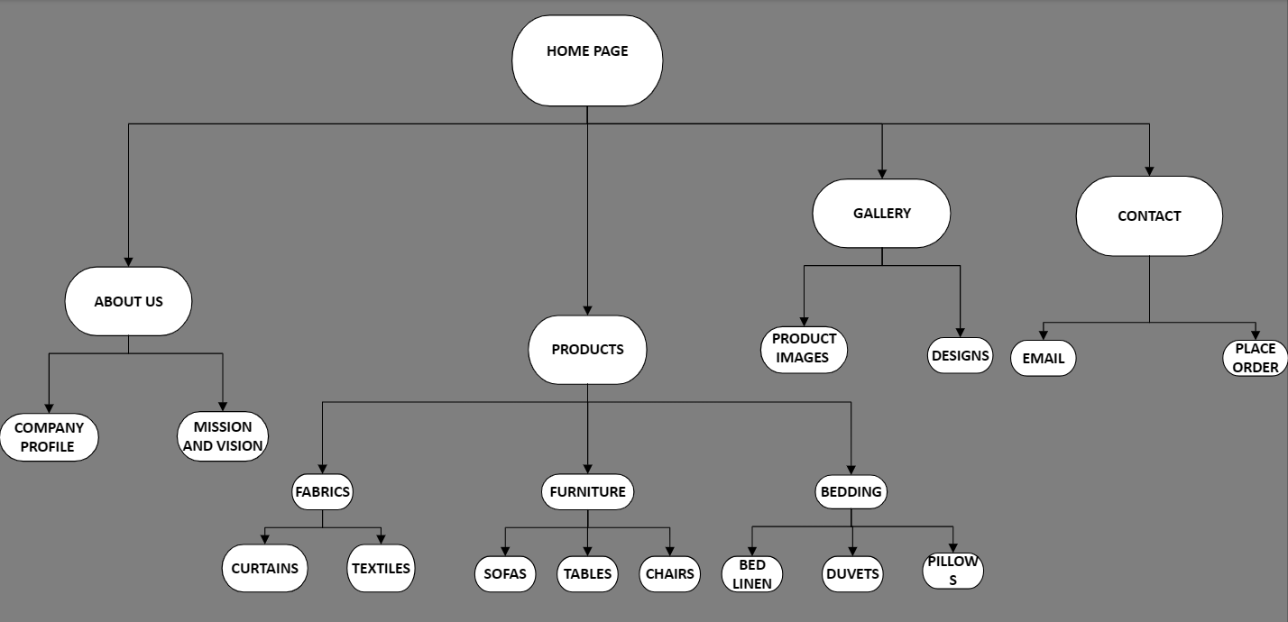

Navigation Structure
The website will use a primary navigation bar located at the top at the centre of each page, providing direct access to all main sections of the site. This ensures consistency across all pages and improves user experience.
Navigation will follow the three-click rule, meaning users will be able to access any important information within a maximum of three clicks. Internal links will also be used within pages to guide users between related content, such as linking product categories to the gallery or contact page.

Storyboard Flow
The storyboard flow describes how the user will interact with the website:
- The user lands on the Home page and views an overview of Citrus Grove and featured visuals.
- The user navigates to the Products page to explore available offerings such as bedding, fabrics and furniture.
- The user may proceed to the Gallery to view visual examples of products and completed designs.
- If interested, the user navigates to the Contact page to make an enquiry.
- The user may also visit the Feedback page to submit comments or reviews.
This flow ensures a smooth and logical user journey from discovery to interaction.
Technical Brief
The development of the Citrus Grove website will utilise a combination of modern web technologies and software tools to ensure that the final product is functional, responsive and visually appealing.
The website will be built using HTML5, CSS3 and JavaScript as the core technologies. HTML5 will be used to structure the content of the website and define the layout of each page. CSS3 will be applied to control the visual design, including colours, typography, spacing and responsive layout across different screen sizes. JavaScript will be used to enhance interactivity, particularly for features such as form validation and dynamic user interactions.
The primary development environment for the project will be Visual Studio Code (VS Code). This tool will provide an efficient workspace for coding, with features such as syntax highlighting and live preview functionality that allow for real-time testing during development.
GitHub will be used as the version control system to manage the website files. Through the use of Git commands, changes to the project will be tracked and maintained throughout the development process. The website will be hosted using GitHub Pages, allowing it to be published and accessed online.
To support the visual design of the website, graphic design tools such as GIMP or Canva will be used to create and edit images, logos and other multimedia elements. These tools will help ensure that the website maintains a consistent and professional appearance that aligns with the Citrus Grove brand.
In addition, the website will be tested across multiple web browsers including Google Chrome, Mozilla Firefox and Microsoft Edge to ensure compatibility and consistent performance. The design will also follow responsive design principles to ensure usability on mobile devices, tablets and desktop computers.
Template Design
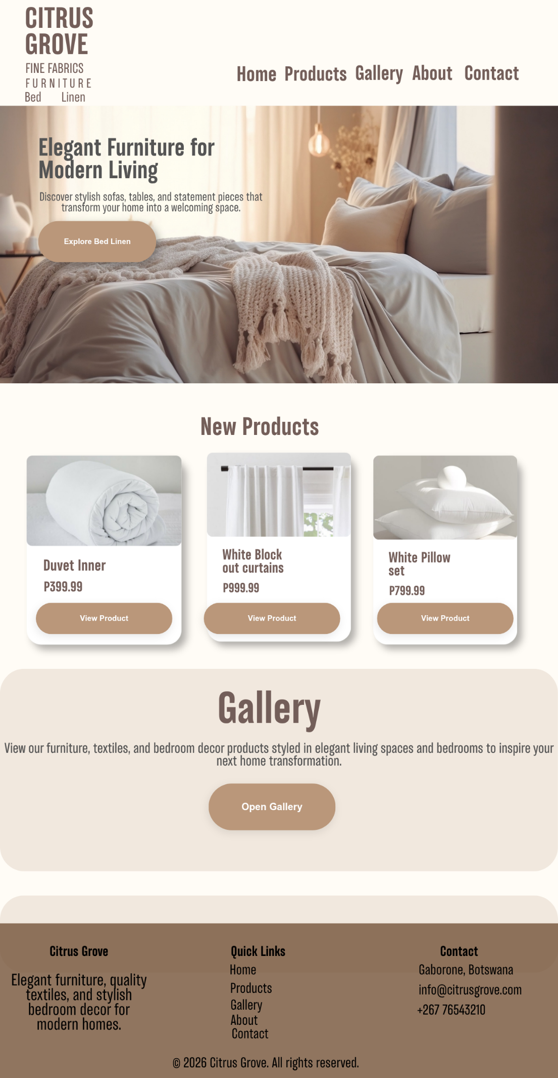
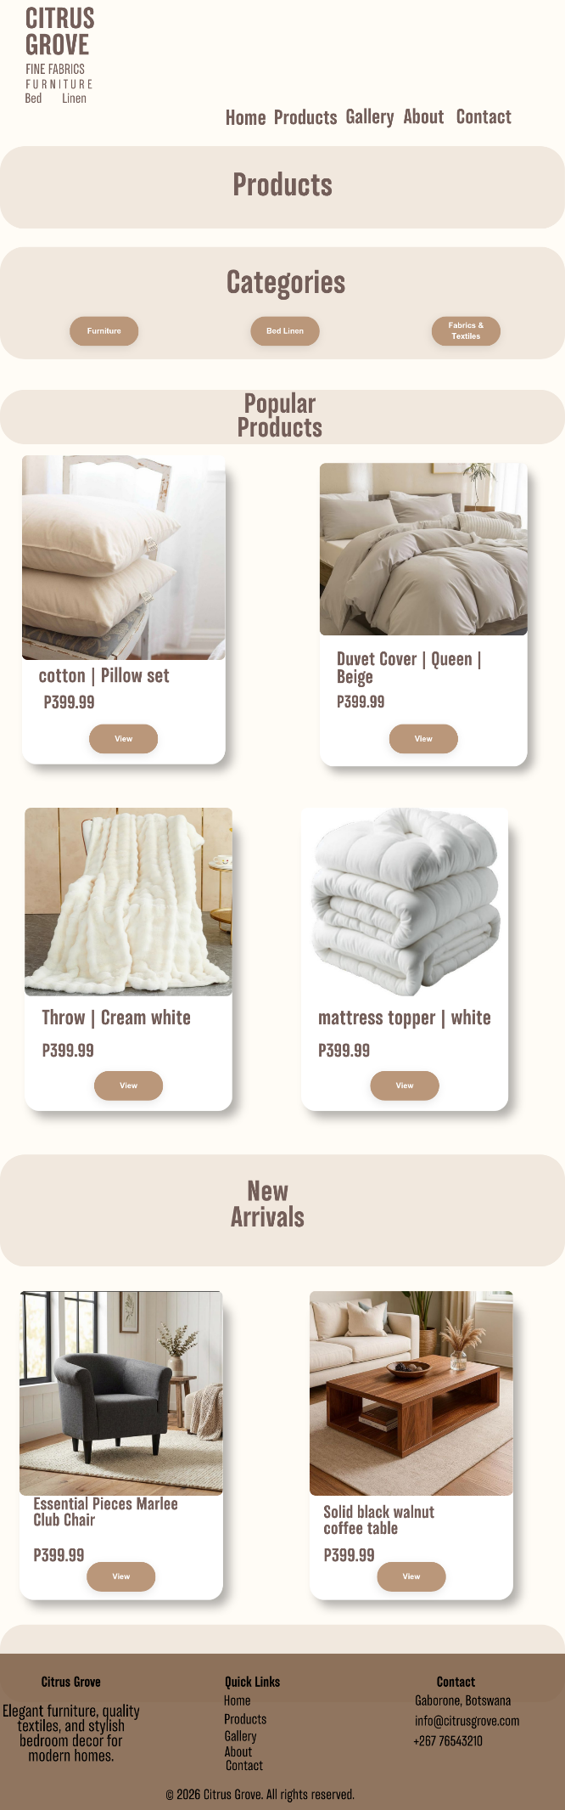
Home page
Products page

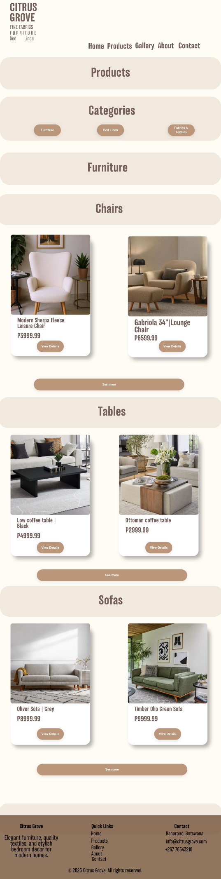
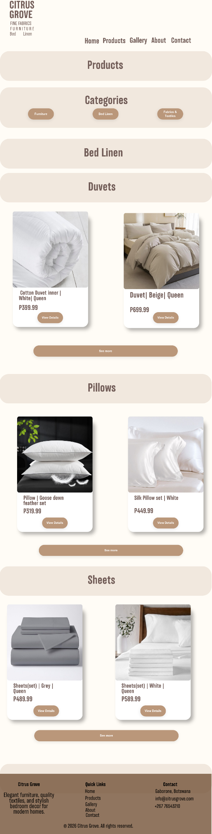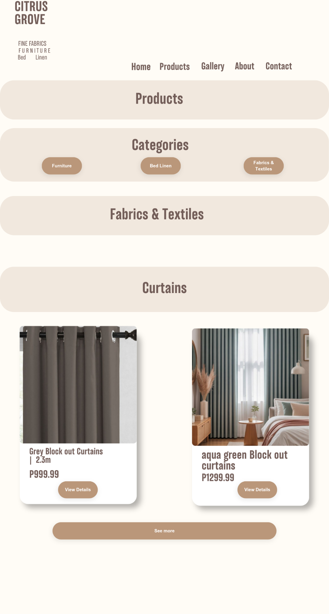
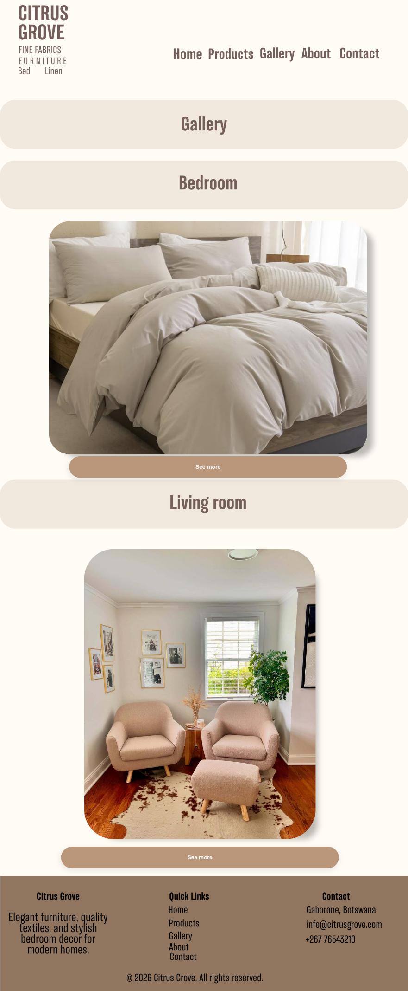
Galle ry page

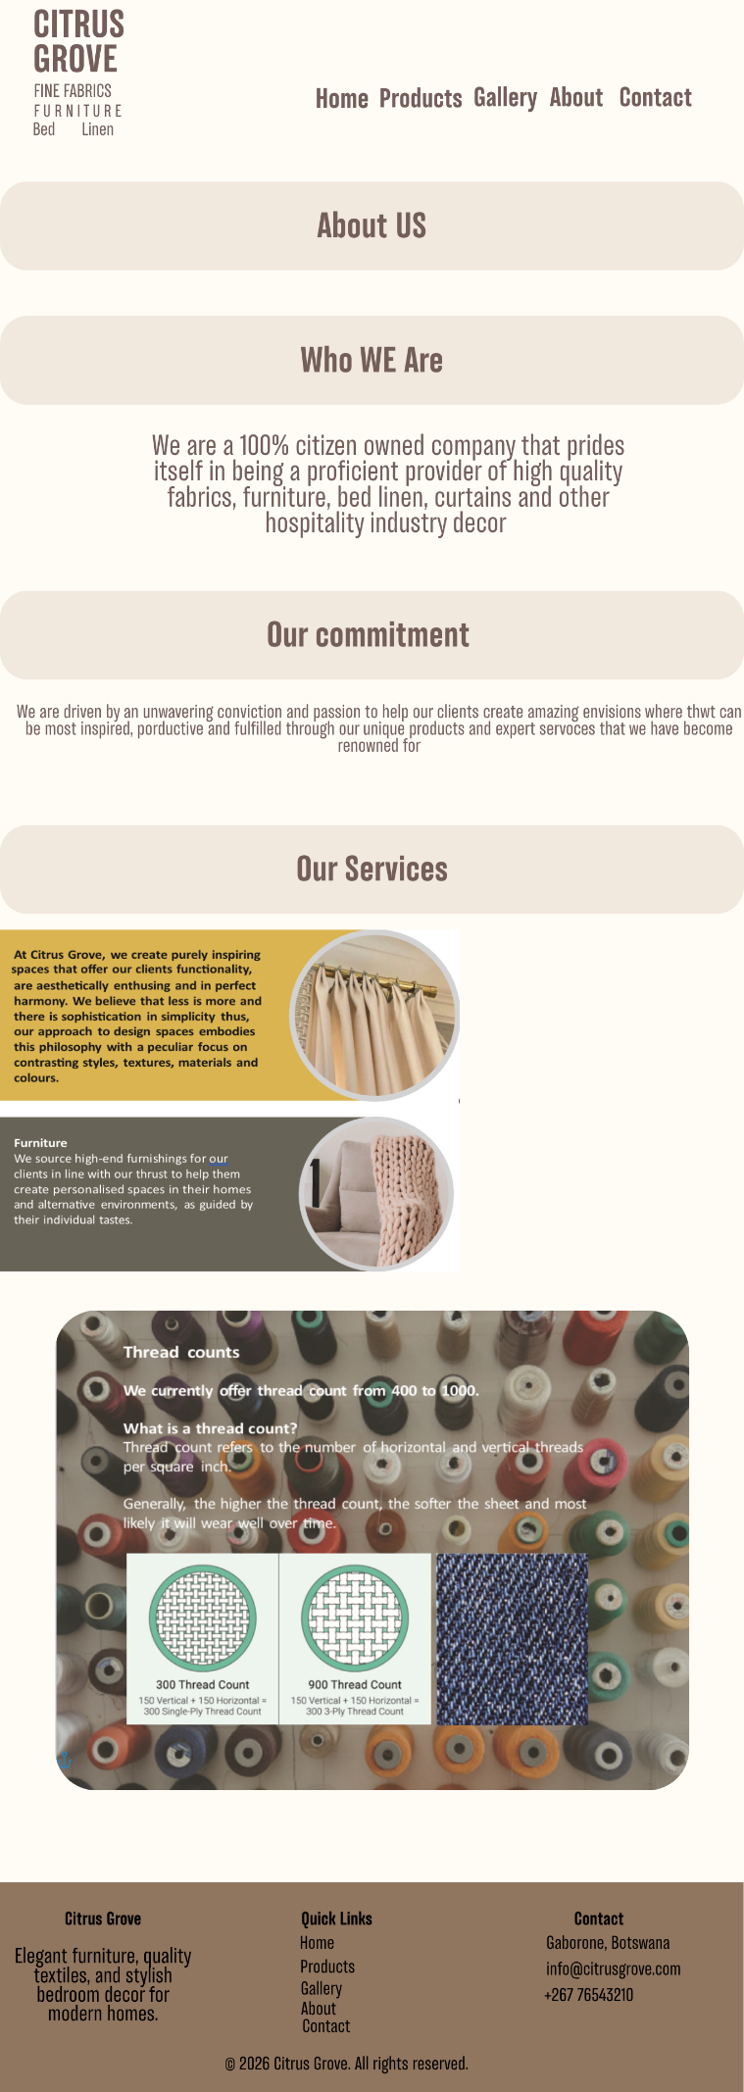
About us page
Contact Page
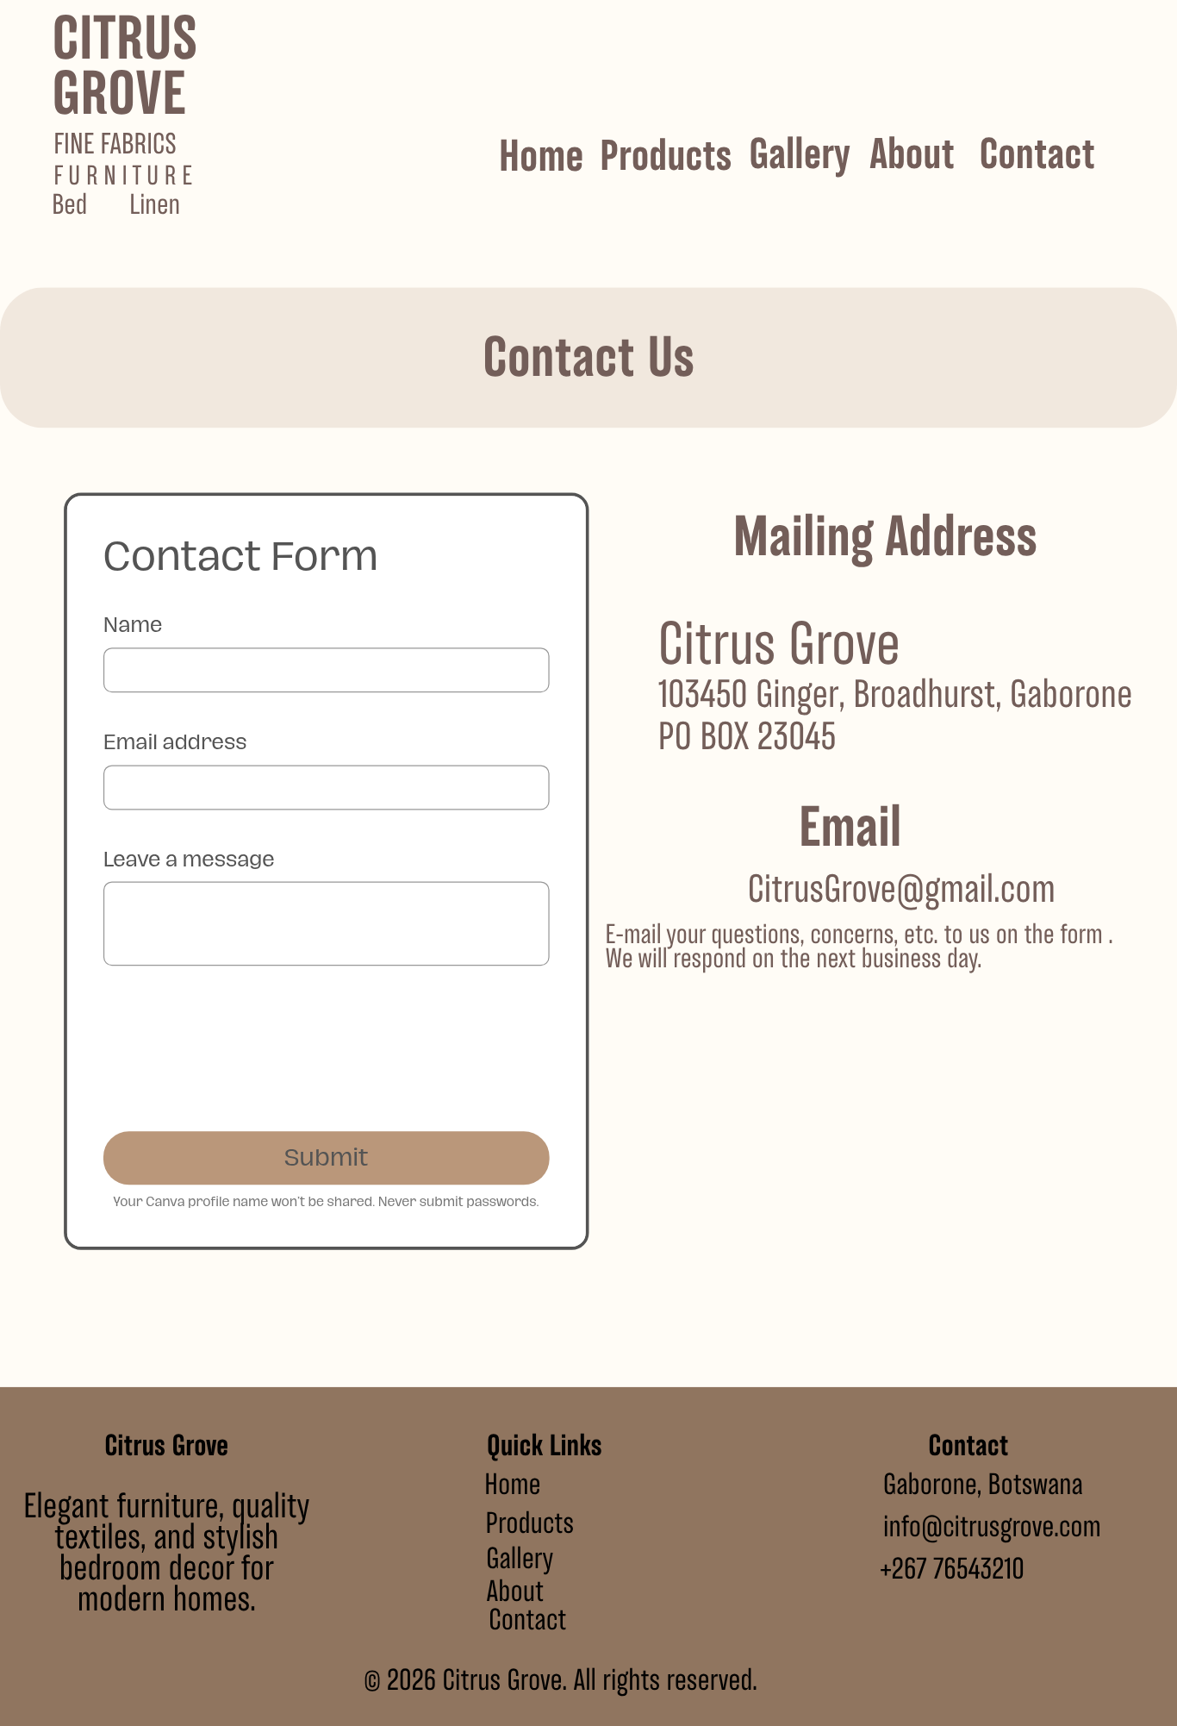
5. the Browser was ran Through compatibility tests and mobile tests. The website was tested on chrome, edge and operaGX and on mobile it was tested on a Samsung A15 .
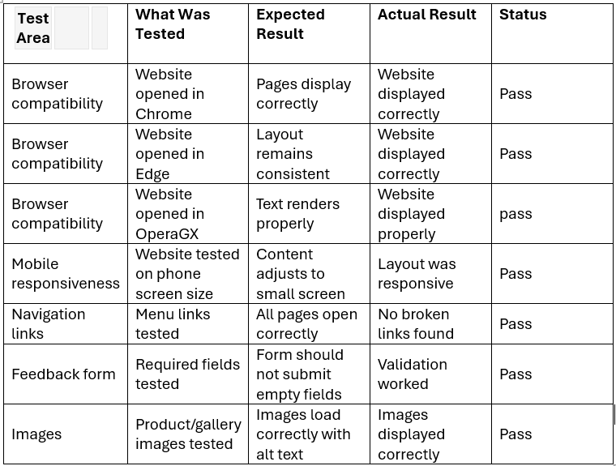
The following are the screenshots of tests
The LCP report shows the render time of large images, text block or video and it is in a good state in all three tested browsers

This is the LCP report on google chrome dev tools
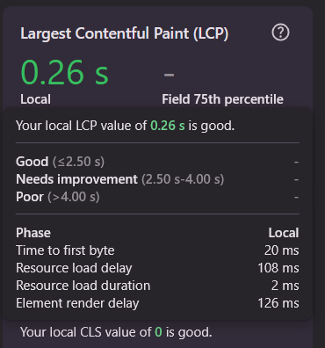
The LCP report on MSEdge
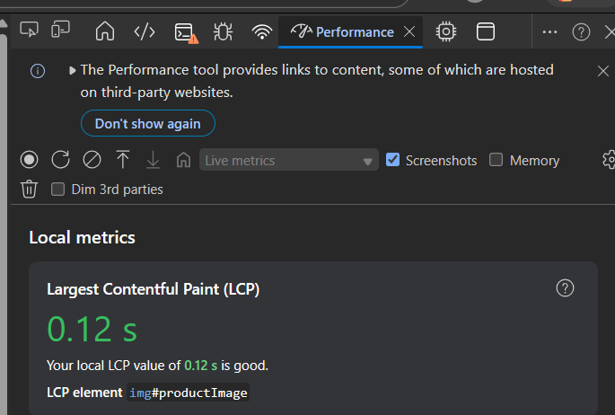

LCP report on OperaGX
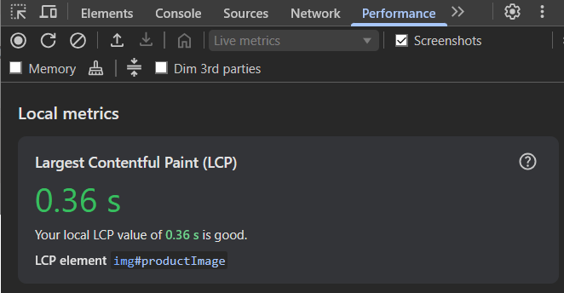
The LCP report shows the render time of large images, text block or video and it is in a good state in all three tested browsers
The website on google chrome
HOME PAGE
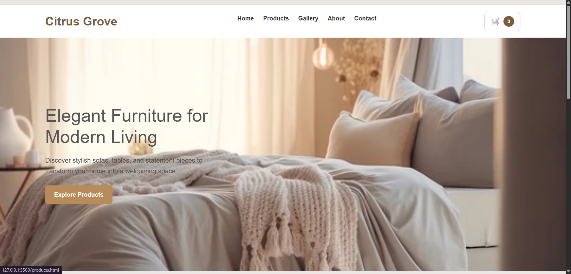
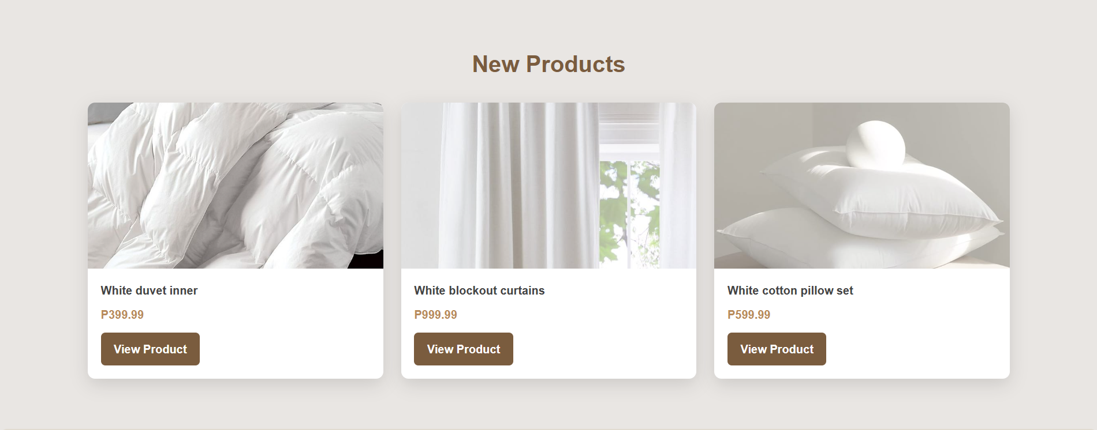

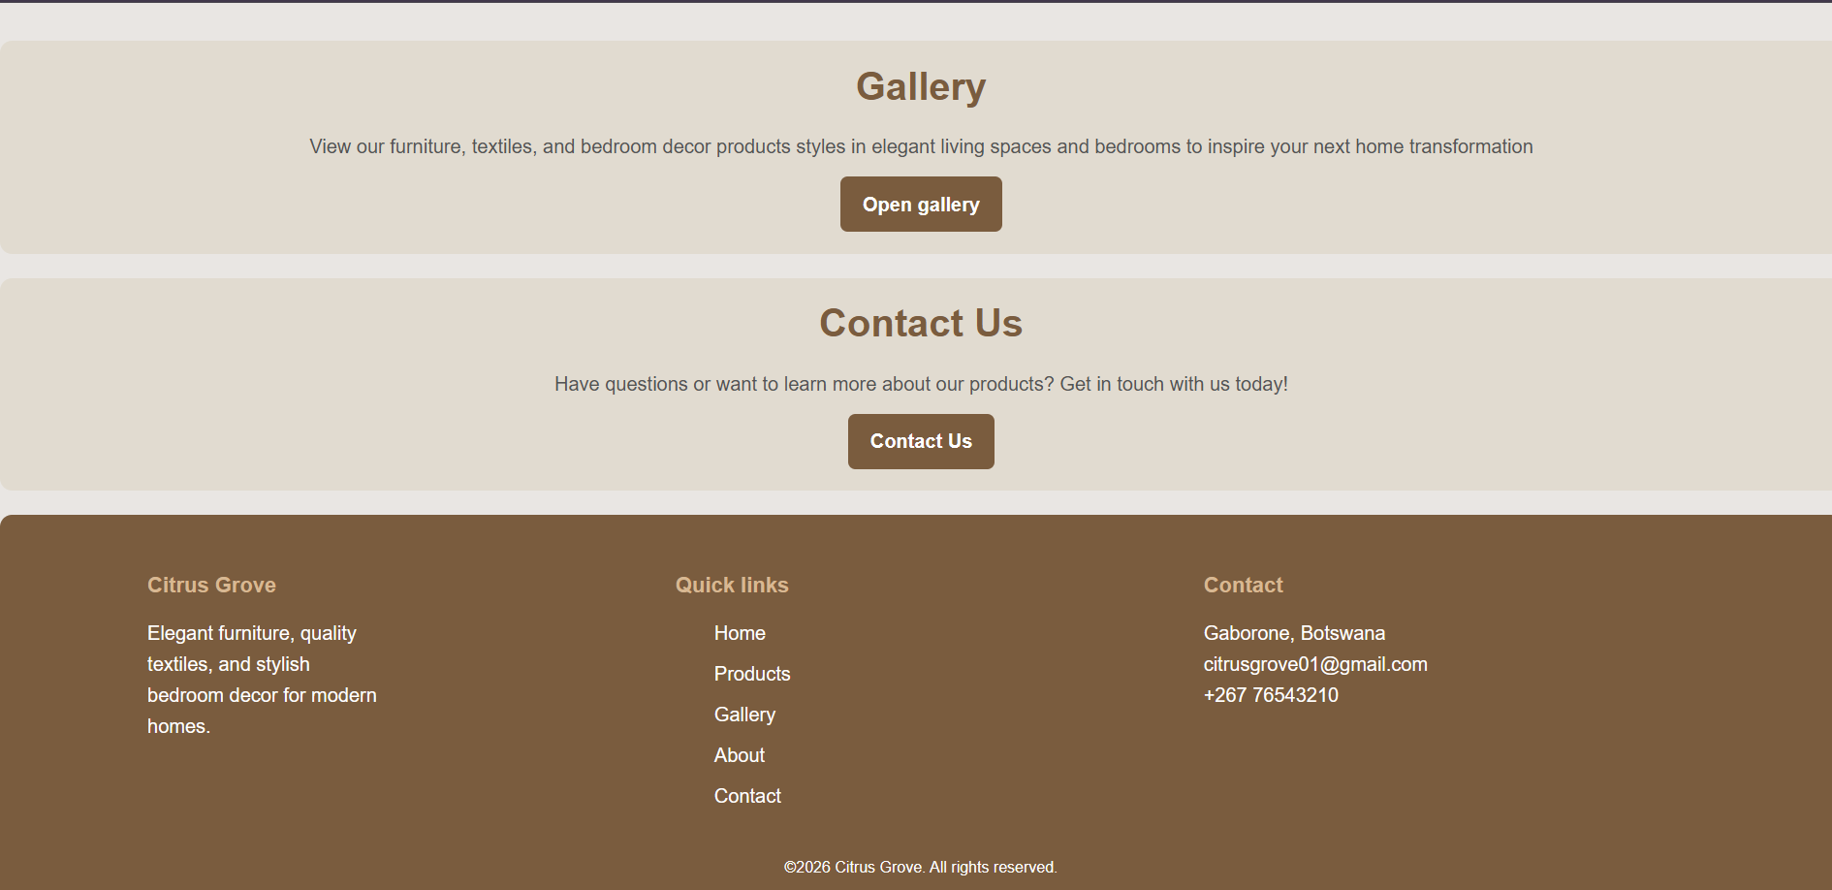

THE WEBSITE ON MICROSOFT EDGE
HOME PAGE
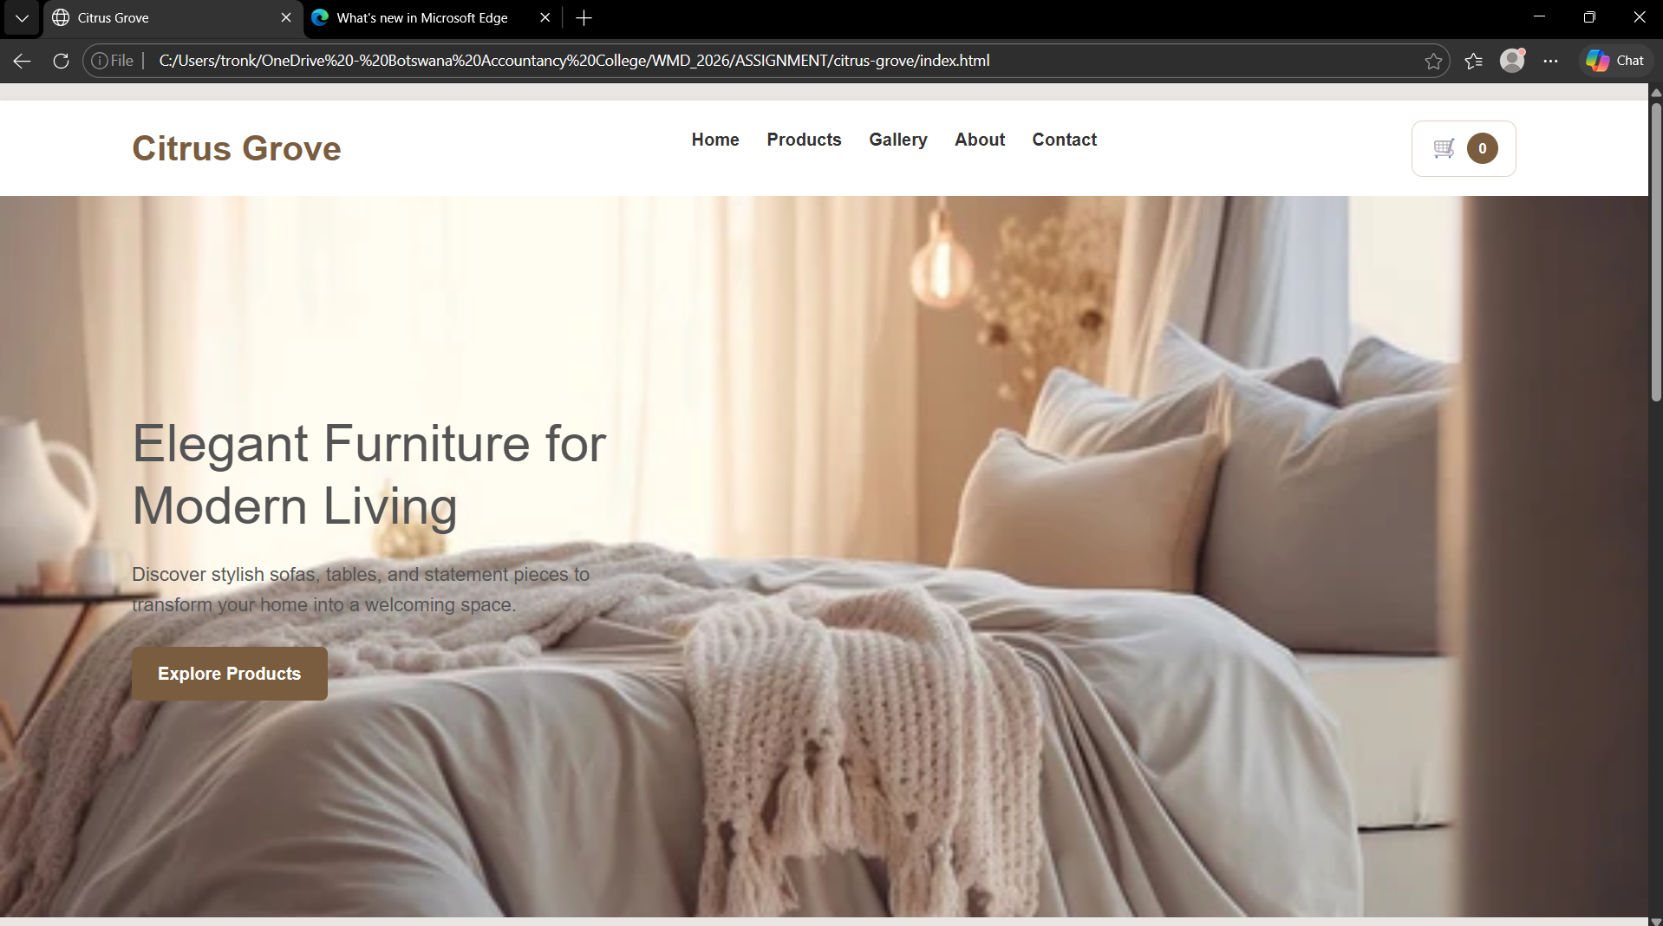

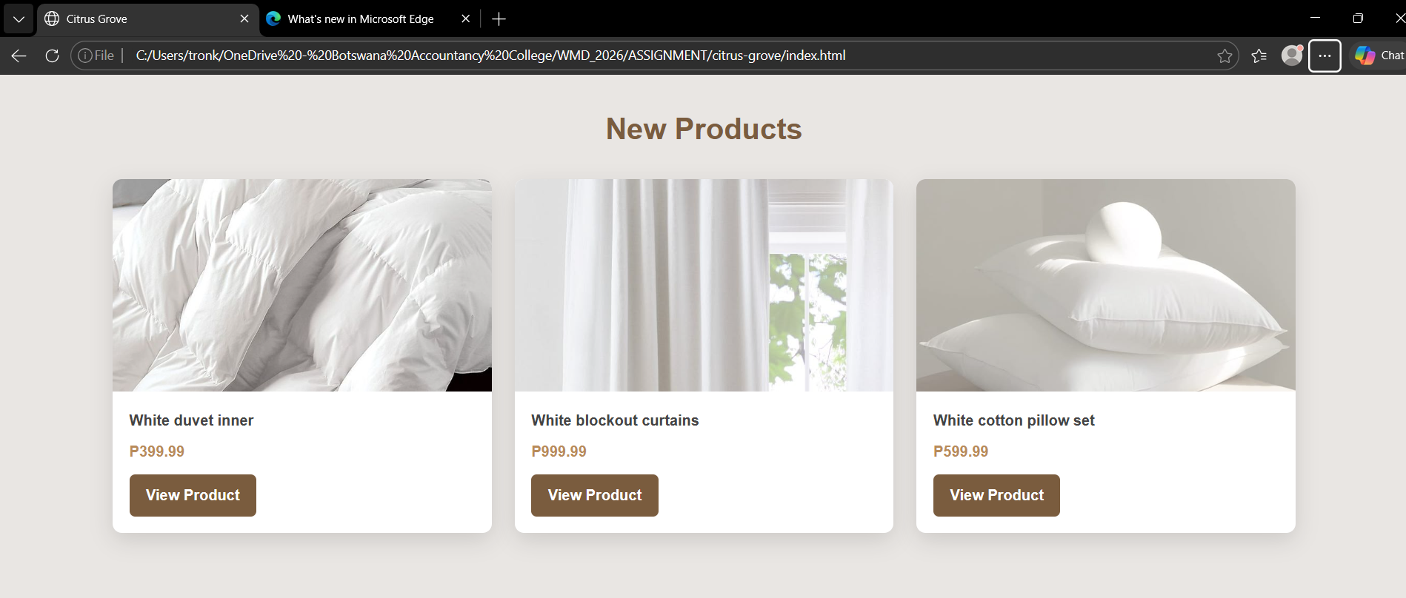

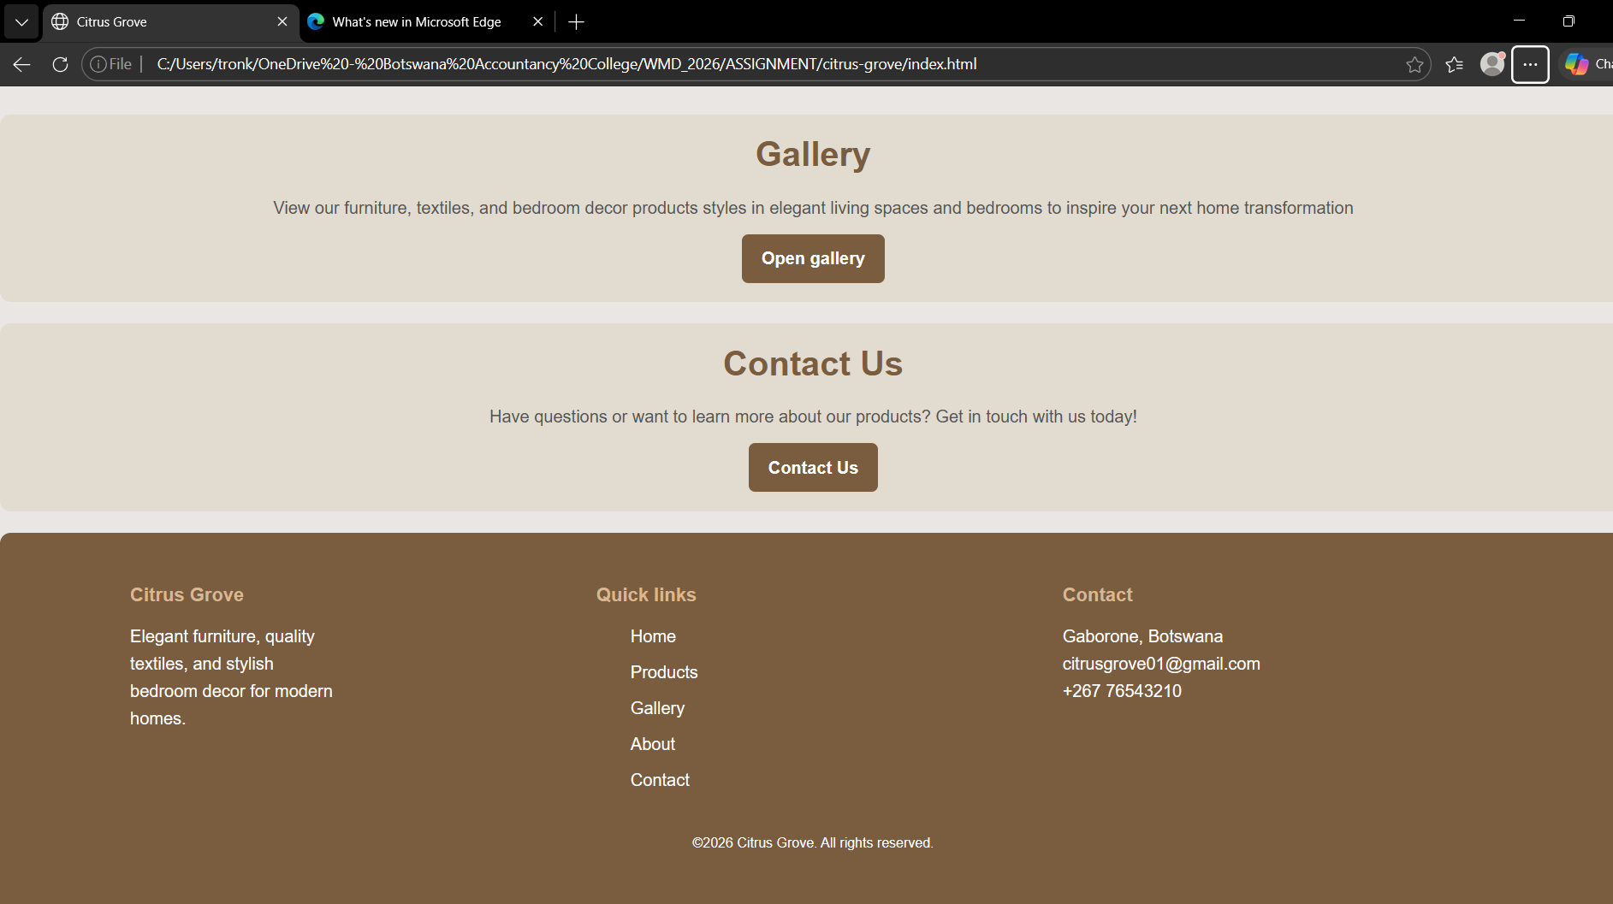

THE WEBSITE ON OperaGX
HOME PAGE
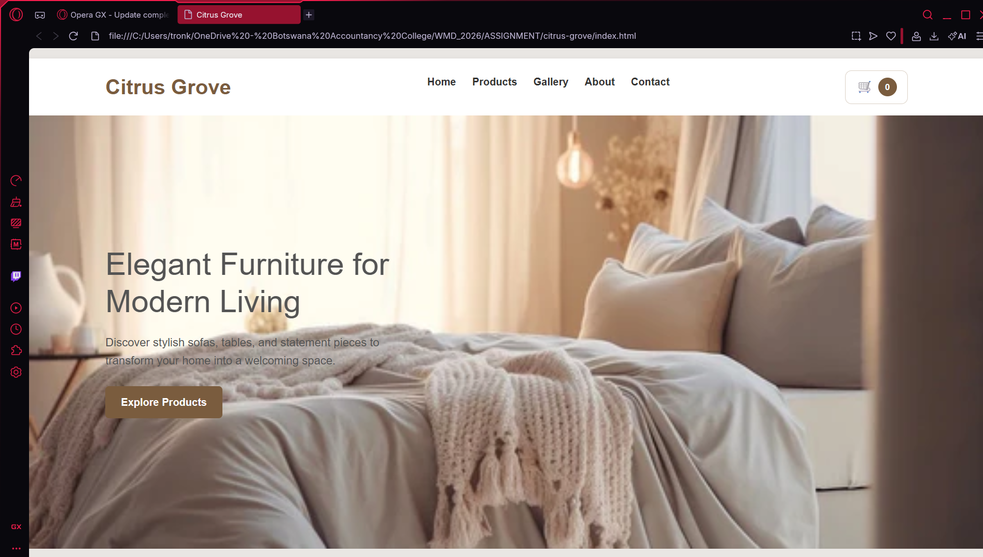
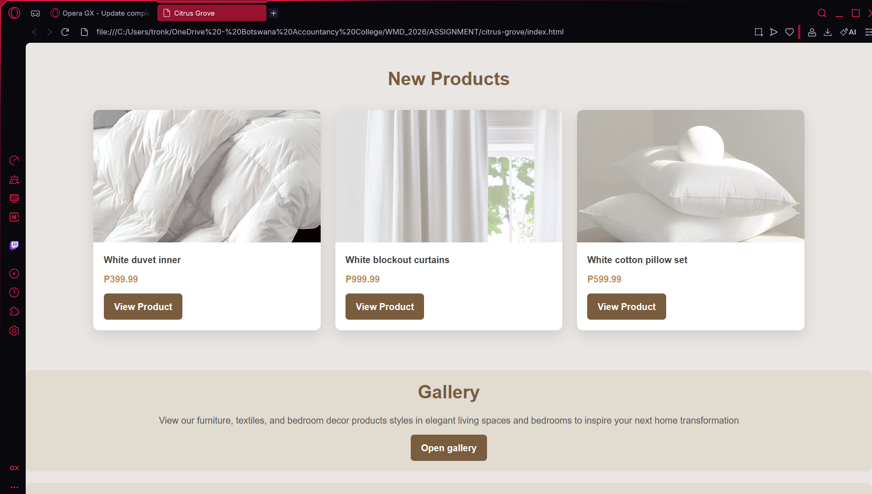

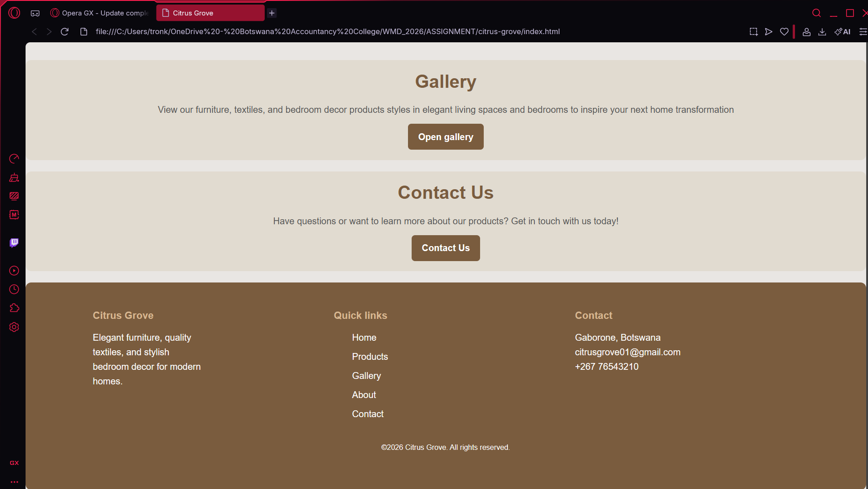

IMAGE RENDERING
Images were rendered properly in this website with no broken link detected while testing on each website. Below is the image test along with their alt text on the three browsers
ON CHROME
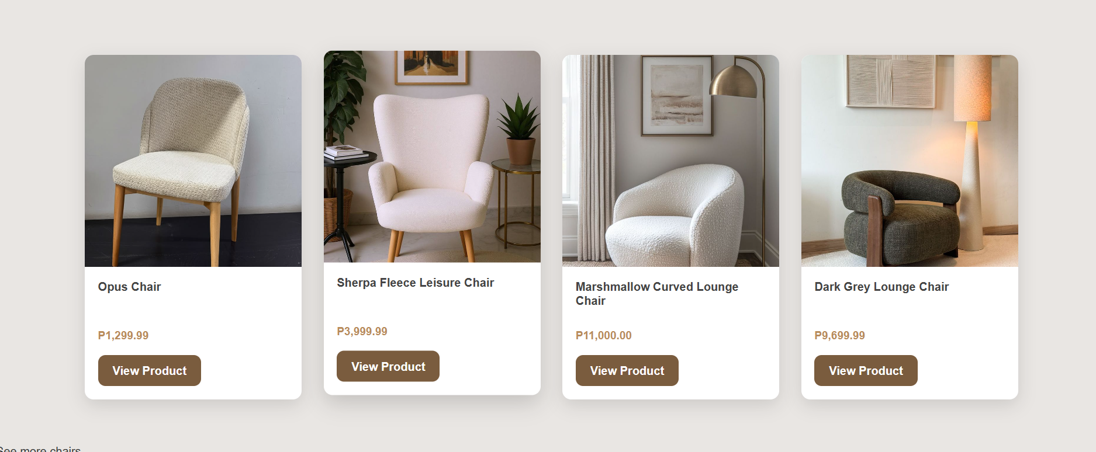

ALT TEXT
